Market Efficiency

Efficient Market Hypothesis

# Random Walk Theory

* Notion that Stock prices are **random** and **cannot be predicted**
* If everyone knew a stock’s price was **going to rise**, everyone would **want to buy** but **no one** would be **willing to sell it –** stock price **rises immediately**
* **Any reasonable forecast** about future performance will instead lead to a **change in the current** performance of the stock, **not in the predicted future**
* Any information that can be used to predict future performance is **already priced** into the stock – this means that prices **only change in response to new information**
  + These changes in prices occur **immediately** as soon as the information is **made public** and **should not have any lingering effect after**
* New information must be **unpredictable (random),** because if they were predictable, they would already be priced into the stock
* 

# Efficient Market Hypothesis

* 
* Known information represents information **about the present** and the **consensus about the future**
  + Earning or other kinds of financial reports reflect *past information*, but they reveal if the **previous consensus was too high or low** – price moves to match the reality
  + They also cause investors to **re-adjust their consensus** about the future which will cause Stock prices to move
* Investors are **constantly doing research** about firms/economy & **trade based off these information –** Different investors have different opinions, but the price eventually stabilizes which represents the **consensus about the future**

## Forms of Efficient Markets

* It is hard to believe that the market is fully efficient – thus we consider three different degrees of the EMH, based on the **type of information considered**:
  + **Market Information** → Historical **trading data** (Price & Volume)
  + **Public Information** → Information **easily found** through Public Sources
  + **Private Information** → **Hard to obtain** information from Private Sources
* Naturally, each type of information is a subset of the following one:
  + Public information contains market information
  + Private information contains both market information and private information
* Thus, if a **higher degree of the EMH holds**, the **lower degrees also hold –** Conversely, if a **lower degree is violated**, all **higher degrees are violated**

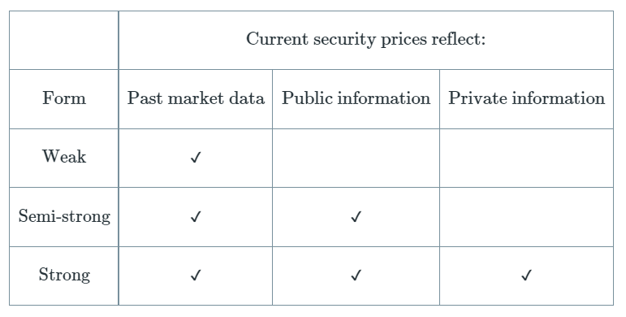

# Key implications of the EMH

* Implications of each specific form:
  + **Weak Form**→ Technical Analysis (TA) is useless
  + **Semi-strong Form** → Basic Fundamental Analysis (FA) is useless
  + **Strong Form** → No form of analysis is useful
* However, this **does NOT mean** that you cannot earn from the stock market, it just means that the return you realise is **proportional to the level of risk taken** – you **cannot earn excess return** above it on a **risk adjusted basis** (“Beating the market”)
* It also **does NOT mean** that NO ONE cannot beat the market – People do **get lucky** and beat the market (~50%) but you **cannot CONSISTENTLY** beat the market
  + Having just a **single person** consistently beat the market is also acceptable as they could be **extremely lucky**
  + **Having a lot of people** consistently beat the market may suggest that the market is not efficient
* EMH is just a **hypothesis** – *not a law of nature like gravity*. It provides some **baseline understanding** of how the markets work, but there are many other factors that influence actual prices which is why *we do in fact* see people beating the market

## Forms of Analysis

* **Technical Analysis** is the **study of patterns** in stock prices. They are hinging on the idea that stock prices **respond predictably**, allowing them to **notice a trend and exploit it**
  + Large based on the **analysis of charts** to find these patterns
  + Key concept is the idea of **Resistance/Support levels** which they believe is hard for the prices to rise above/fall below
* **Fundamental Analysis** is the study of **earnings prospects** to determine the **proper stock prices** (DCF). If this value is **different from the current prices**, stocks are hence **under or overvalued** & thus should be bought or sold
  + Making a **good analysis is useless** if everyone else also came to that conclusion – the key is to make a **better analysis** than others that is not reflected in the price
  + It is hard to make a better analysis with just public information; many financial firms **spend resources** conducting market research to **uncover private data**, but even then, it is hard to uncover something not noticed by rivals as well

**Supporting Evidence**

# Weak Form Evidence

## Random Walk Theory

* Analysis of historical prices found that stock prices **vary randomly** from day to day
* Thus, historical market data such as prices CANNOT be used to predict future stock prices

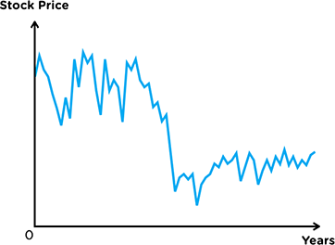

## No Autocorrelation

* Analysis of historical stock prices found that there is **no autocorrelation** (White Noise) between consecutive daily returns
* Thus, historical market data such as prices CANNOT be used to predict future stock prices

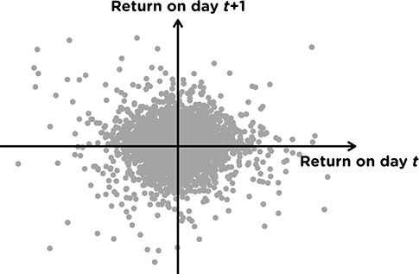

# Semi Strong Form Evidence

* Analysis of stock prices before and after major news releases:
  + Earnings Announcements
  + Merger or Takeover intentions (Focus of the study)
  + Macro-Economic Indicators
* Measured based on **Abnormal Return** - Difference between Actual Price and Expected Price (CAPM)
* Abnormal Return spiked **immediately** on the release of the news announcement & showed **no trend thereafter**
* Thus, stock prices reacted instantly to news and CANNOT be retroactively used for excess returns

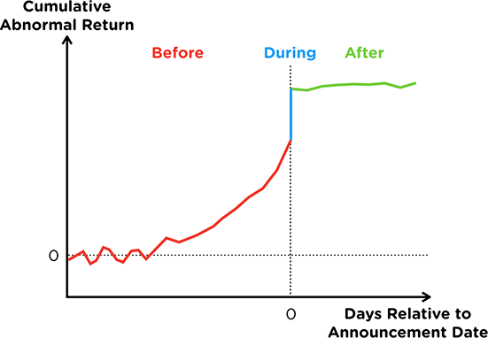

# Strong Form Evidence

* Analysis of professionally managed funds which conduct extensive analysis of companies, industry and the economy as a whole
  + These funds were only able to beat the index 40% of the time over a 40 year timespan
  + Funds who beat the market in only had a 50% chance to beat the index the following year
  + These funds also charge fees, which will offset any excess returns or even destroy value if there are no excess returns
* Thus, professional fund managers CANNOT consistently beat the market, suggesting that even private information cannot be used for excess returns

**Evidence Against**

# Market Anomalies

* They refer to events that CANNOT be explained by the Efficient Market Hypothesis
* Market Anomalies are of great interest to investors as they represent a **way to earn higher returns**
* However, NOT ALL market anomalies can be treated as evidence against the EMH
  + Some anomalies may be **explainable through risk**, which would justify its excess return
  + Some anomalies may be found as a result of **Data Mining** (Coincidence), which would mean that it cannot be replicated

## Calendar Anomalies

|  |  |  |
| --- | --- | --- |
| January Effect | Higher returns in January Lower returns in December | Due to sell offs in December for Tax purposes Also due to portfolio rebalancing in January |
| Monday Effect (Weekend Effect) | Lower Returns on Monday Higher Returns on Friday | Due to bad news over the weekend Also due to pessimism as people return to work |
| Time of Day Effect | Open & Close more volatile |  |

## Under or Over Reaction Anomalies

* Investor Under Reaction
  + Small Positive/Negative reaction now
  + Realise that they under reacted, compensate with a larger future reaction in the same direction
  + **Momentum** in stock prices as it changes in the **same direction**
* **Investor Over Reaction**
  + Large Positive/negative reaction now
  + Realise that they over reacted, compensate with a **smaller future opposite reaction**
  + **Reversal** in stock prices as it changes in the **opposite direction**

|  |  |
| --- | --- |
| **Long Run IPO Underperformance** | Reversal in returns following good IPO performance |
| **Post Earnings Announcement Drift** | Momentum in Returns following earnings announcements |
| **Short Term Momentum** | Momentum in returns for stocks with good performance |
| **Long Term Reversal** | Reversal for stocks with poor performance |

## Other Anomalies

|  |  |
| --- | --- |
| **Size Effect** | Small stocks (market cap) have higher returns, vice-versa |
| **Value Effect** | Value stocks (Low P/E, M/B) have higher returns, vice-versa |
| **Siamese Twins** | Identical stocks should have the same prices but they often do not |
| **Political Cycle Effect** | Returns are higher on the first and last year of the political administration |
| **Stock Split Effect** | Returns are higher before and after announcement of stock split |
| **Neglected Firm Effect** | Neglected stocks are under the radar and hence earn higher returns |
| **Super Bowl Effect** | Returns are positively correlated to the NFC team winning the Superbowl |

# Asset Bubbles

* Stock prices trades **significantly higher** than its fair value
* Usually starts with a **rapid run up** in the price of a security
  + Creates the expectation that the price will continue to rise, which **attracts more people** to come & hence **pushes the prices even higher** (*Bubble*)
* Once the run-up stalls, everybody begins to **sell off**, causing the price to **rapidly decrease** (*Burst*)
* Bubbles seemingly have some “rational reasoning” while the bubble is rising, but only in retrospect that people in fact realise it was a bubble
* Recent Bubbles:
  + **Japanese Stock & Real Estate**, 1980s
  + **Dot Com Bubble**, 1990s
  + **US Housing Bubble**, 2000s

**Behavioural Finance**

# Efficiency of the Market Portfolio

* From CAPM, one key conclusion was that the Market Portfolio is efficient - there is NO other portfolio that can earn a greater return than it on a **risk adjusted basis** ("Market Efficiency")
* Thus, regardless of skill level, all investors *should* hold on to the Market Portfolio to earn the average market return (Since they cannot earn a better return)
* However, the Market Portfolio may not always be efficient:

|  |  |
| --- | --- |
| **Proxy Error** | Market Portfolio does not exist  Proxy Portfolio (EG. S&P500) is not efficient |
| **Behavioural Biases** | Investor decisions are systematically biased in one direction  Trade assets that reflect this bias |
| **Alternative Risk Preferences** | Investors care about aspects *other* than Risk & Return  Trade assets that match their preferences |
| **Non-Tradeable Wealth** | Investors are exposed to risk *outside* of investments **Exclude** assets from portfolio that are related to the risk |

* For the bottom three points, since investors hold different portfolios in systematic ways, this bids the price of certain assets up or down
* Thus, holding all possible assets **may no longer be efficient**

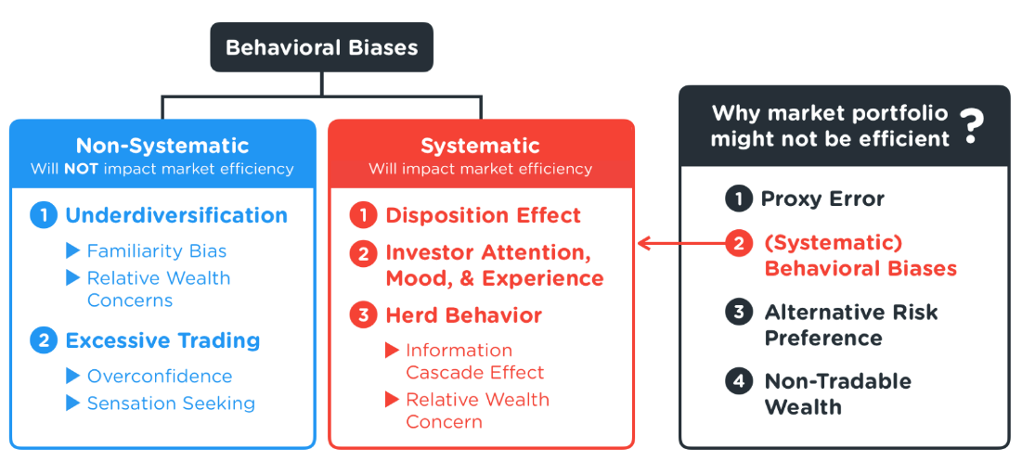

# Behavioural Finance

* It is the study of how human behaviour affects financial markets
* We focus on how **inherent cognitive biases** affect decision making in terms of portfolio construction

## Non-Systematic Biases

* These cognitive biases occur at an individual level
* Some individuals experience these biases while others do not - on average they will offset each other and the prices of assets (& hence efficiency)remain unchanged

### Bias #1: Under-Diversification

* Investors can reduce their risk by holding a large number of **different kinds** of stocks
* But investors often end up holding closely related in terms of Geography or Industry

|  |  |
| --- | --- |
| **Familiarity Bias** | Prefer investments that they are **exposed to/familiar with**  Results in an **under-diversified** portfolio |
| **Relative Wealth Concerns** | Concerned about portfolio performance **relative to peers** Choose an **under-diversified** portfolio hoping to earn more |

### Bias #2: Excessive Trading

* Investors holding the market portfolio should not require many trades to rebalance
* But there are large volume of trades each day - results in higher transaction cost & lowering return

|  |  |
| --- | --- |
| **Overconfidence** | Overestimate their ability to pick winners and losers  Results in excessive trading to form portfolio |
| **Sensation Seeking** | People desire risk taking experiences Trade more to take on more risk |

## Systematic Biases

* These cognitive biases occur systematically thus affect a large number of investors
* Their effects DO NOT offset one another, thus affecting the price of assets (& hence efficiency)

### Bias #1: Disposition Effect (Loss Aversion)

* Investors hate losses more than they like getting gains
* Thus, they tend to hold on to losing positions and let go of winning positions
* Avoid realising losses and instead realise gains, which results paying higher capital gains taxes
* Additionally, due to the momentum effect, they worsen their position and miss out on potential gains

**Bias #2: Investor Attention, Mood & Experience**

* **Limited Attention Spans** → More influenced by attention grabbing information
* **Affective Feelings** → More influenced by external/non-financial news or events
* **Experience Effects** → More weight on personal experience than objective information
* Results in holding stocks that are significantly different from the Market Portfolio

**Bias #3: Herd Behaviour**

* Investors try to follow each other's behaviour → If one person deviates, many people deviate
  + **Information Cascade** → Believe that other investors have superior information; follow them
  + **Relative Wealth Concerns →** Avoid losing out by copying their trades
  + **Manager Reputation** → Avoid being too (negatively) different from their peers